TASK 11- CRUD OPERATIONS IN GRAPH DATABASES

AIM:
To perform CRUD operations like creating, inserting, querying, finding, deleting operations on graph spaces.

- Create Node with Properties
Properties are the key-value pairs using which a node stores data. You can create a node with properties using the CREATE clause. You need to specify these properties separated by commas within the flower braces “{ }”.

Syntax
Following is the syntax to create a node with properties.
CREATE (node:label { key1: value, key2: value, . . . . . . . . . })

- Returning the Created Node
To verify the creation of the node, type and execute the following query in the dollar prompt.
MATCH (n) RETURN n

- Creating Relationships
We can create a relationship using the CREATE clause. We will specify relationship within the square braces “[ ]” depending on the direction of the relationship it is placed between hyphen “ - ” and arrow “ → ” as shown in the following syntax.

Syntax
Following is the syntax to create a relationship using the CREATE clause.
CREATE (node1)-[:RelationshipType]->(node2)

- Creating a Relationship Between the Existing Nodes
You can also create a relationship between the existing nodes using the MATCH clause.

Syntax
Following is the syntax to create a relationship using the MATCH clause.
MATCH (a:LabeofNode1), (b:LabeofNode2)
WHERE a.name = "nameofnode1" AND b.name = " nameofnode2"
CREATE (a)-[: Relation]->(b)
RETURN a,b

- Deleting a Particular Node
To delete a particular node, you need to specify the details of the node in the place of “n” in the above query.

Syntax
Following is the syntax to delete a particular node from Neo4j using the DELETE clause.
MATCH (node:label {properties . . . . . . . . . . })
DETACH DELETE node

Create a graph database for student course registration, create student and dept node and insert values of properties.

create(n:student{Sid: "VTU14500",
Sname:"John",
deptname:"CSE" }
)
OUTPUT
Added 1 label, created 1 node, set 3 properties, completed after 232 ms.

Create(n:student {Sid: "VTU14501",
Sname:"Dharsana",
deptname:"EEE"})

OUTPUT
Added 1 label, created 1 node, set 3 properties, completed after 16 ms.

Create(w:student { Sid: "VTU14502",
Sname:"vijay",
deptname:"CSE"
})

OUTPUT
Added 1 label, created 1 node, set 3 properties, completed after 12 ms.

Create(n:dept{deptname:"cse",deptid:"d001"})

OUTPUT:
Added 1 label, created 1 node, set 2 properties, completed after 72 ms.

Select all the nodes in your database using match command

- match(n) return(n)

OUTPUT
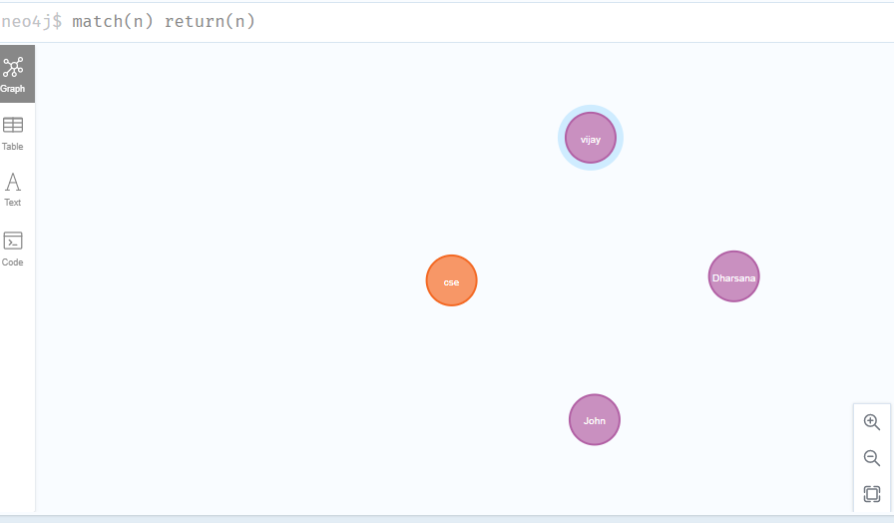

- match(n:student) return(n)

OUTPUT:

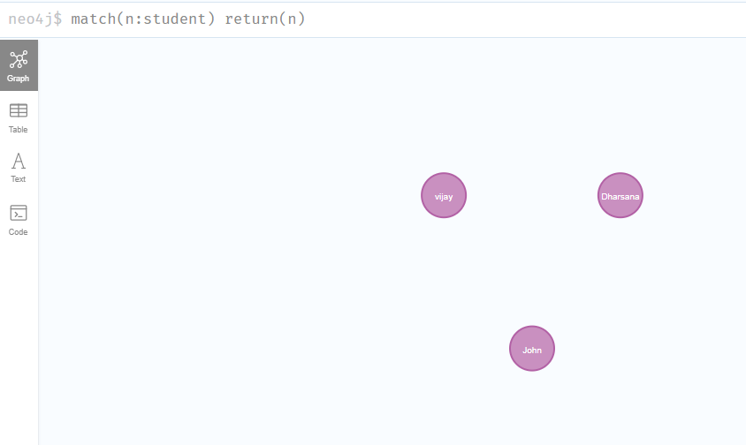

- Create relationship between student and cse .

MATCH(s:student),(d:dept) WHERE s.Sname ='vijay' AND d.deptname='cse'
CREATE(s)-[st:STUDIED_AT]->(d)
return s,d

OUTPUT:
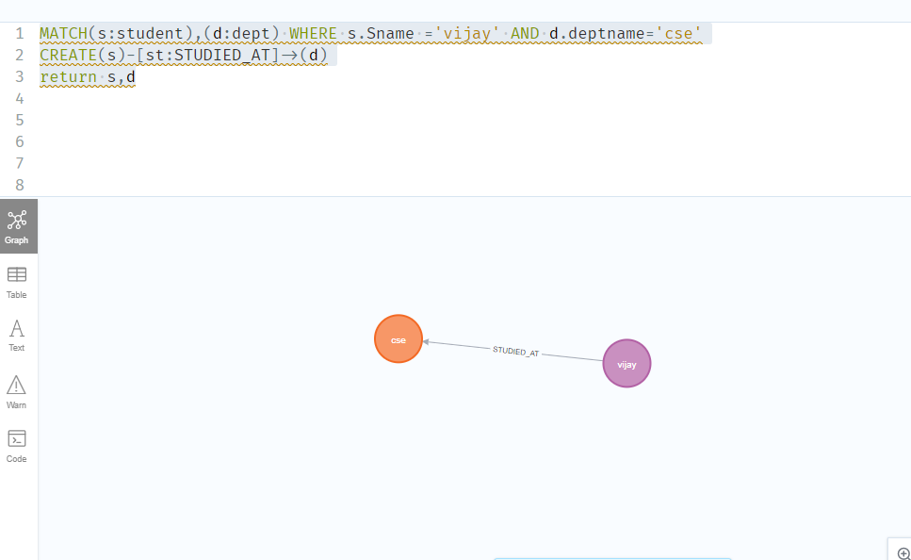

MATCH(s:student),(d:dept) WHERE s.Sname ='John' AND d.deptname='cse'
CREATE(s)-[st:STUDIED_AT]->(d)
return s,d

OUTPUT:

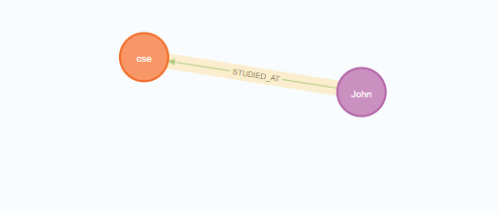

match(n) return(n)
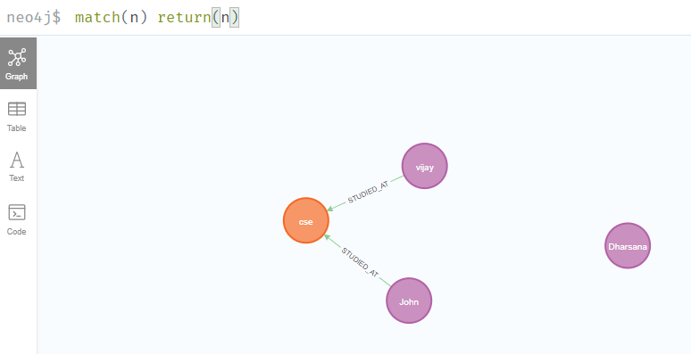

- Delete a node from student

match(n:student{Sname:'Dharsana'}) DELETE(n)

OUTPUT:
Deleted 1 node, complaeted after 10834 ms.
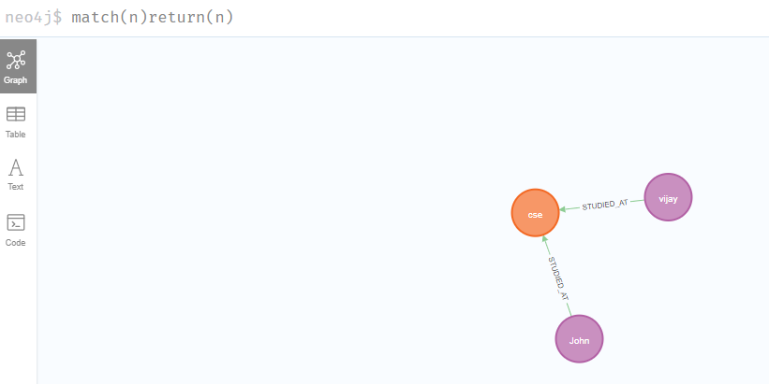

Result
The implementation of CRUD operations like creating, inserting, finding and removing operations using GraphDB is successfully executed.

